Chapter 8  
*Classification Methods*

Exercise 8.8

1. Classiﬁcation tree of Golub data. Use recursive partitioning in rpart
2. Find a manner to identify an optimal gene with respect the Golub data to prediction of the ALL AML patients.

Variable predictor dari nilai ekspresi gen adalah gen CCND3 Cyclin D3. Sintaks program dengan menggunakan bahasa pemrograman R, sebagai berikut:

> #Ex 3

> library(rpart);data(golub); library(multtest)

> gol.fac <- factor(golub.cl,levels=0:1, labels= c("ALL","AML"))

> gol.rp <- rpart(gol.fac ~ golub[1042,] , method="class")

> predictedclass <- predict(gol.rp, type="class")

> table(predictedclass, gol.fac)

gol.fac

predictedclass ALL AML

ALL 25 1

AML 2 10

> predict(gol.rp,type="class")

1 2 3 4 5 6

7 8 9 10 11 12 13 14 15 16 17 18 19 20 21 22 23 24 25

ALL ALL ALL ALL ALL ALL ALL ALL ALL ALL ALL ALL ALL ALL ALL ALL AML ALL ALL ALL AML ALL ALL ALL ALL

26 27 28 29 30 31 32 33 34 35 36 37 38

ALL ALL AML ALL AML AML AML AML AML AML AML AML AML

Levels: ALL AML

> boxplot(golub[2124,] ~gol.fac)

> summary(gol.rp)

Call:

rpart(formula = gol.fac ~ golub[1042, ], method = "class")

n= 38

CP nsplit rel error xerror xstd

1 0.7272727 0 1.0000000 1.0000000 0.2541521

2 0.0100000 1 0.2727273 0.3636364 0.1719828

Variable importance

golub[1042, ]

100

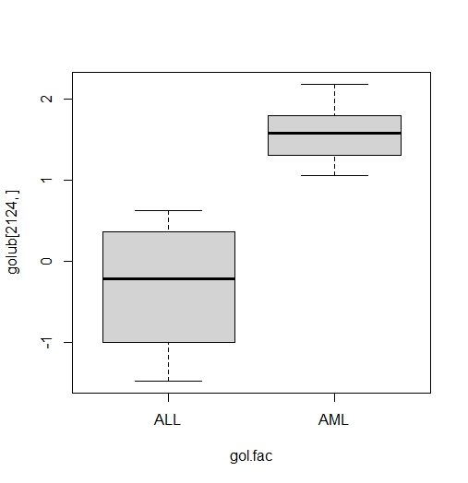

Node number 1: 38 observations, complexity param=0.7272727

predicted class=ALL expected loss=0.2894737 P(node) =1

class counts: 27 11

probabilities: 0.711 0.289

left son=2 (26 obs) right son=3 (12 obs)

Primary splits:

golub[1042, ] < 1.198515 to the right, improve=10.37517, (0 missing)

Node number 2: 26 observations

predicted class=ALL expected loss=0.03846154 P(node) =0.6842105

class counts: 25 1

probabilities: 0.962 0.038

Node number 3: 12 observations

predicted class=AML expected loss=0.1666667 P(node) =0.3157895

class counts: 2 10

probabilities: 0.167 0.833

> golub.gnames[2124,]

[1] "4847" "Zyxin" "X95735_at"

> predict(gol.rp, type="prob")

ALL AML

1 0.9615385 0.03846154 20 0.9615385 0.03846154

2 0.9615385 0.03846154 21 0.1666667 0.83333333

3 0.9615385 0.03846154 22 0.9615385 0.03846154

4 0.9615385 0.03846154 23 0.9615385 0.03846154

5 0.9615385 0.03846154 24 0.9615385 0.03846154

6 0.9615385 0.03846154 25 0.9615385 0.03846154

7 0.9615385 0.03846154 26 0.9615385 0.03846154

8 0.9615385 0.03846154 27 0.9615385 0.03846154

9 0.9615385 0.03846154 28 0.1666667 0.83333333

10 0.9615385 0.03846154 29 0.9615385 0.03846154

11 0.9615385 0.03846154 30 0.1666667 0.83333333

12 0.9615385 0.03846154 31 0.1666667 0.83333333

13 0.9615385 0.03846154 32 0.1666667 0.83333333

14 0.9615385 0.03846154 33 0.1666667 0.83333333

15 0.9615385 0.03846154 34 0.1666667 0.83333333

16 0.9615385 0.03846154 35 0.1666667 0.83333333

17 0.1666667 0.83333333 36 0.1666667 0.83333333

18 0.9615385 0.03846154 37 0.1666667 0.83333333

19 0.9615385 0.03846154 38 0.1666667 0.83333333

1. Explain what the code does.

Berdasarkan data Golub dkk (1999), nilai ekspresi gen dapat dibentuk suatu *decision tree*, yang memberikan prediktor, jika terdapat banyak prediktor maka fungsi **rpart** secara otomatis memilih gen yang berpengaruh dalam pengklasifikasian. Berdasarkan boxplot yang dihasilkan, dapat diketahui bahwa gen A merupakan prediktor ideal untuk membagi-bagi pasien ke dalam beberapa kelas. Data pasien ALL dan AML diklasifikasikan berdasarkan gen CCND3 Cyclin D3.

1. Use rpart to construct the classiﬁcation tree with the genes that you found. Does it have perfect predictions?

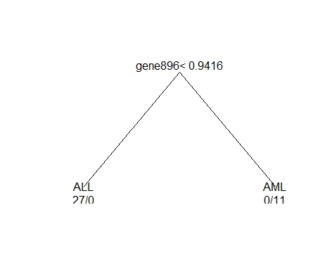 Iya, itu merupakan prediksi yang sempurna dengan menentukan ekspresi gen sebagai variabel, kemudian mengubah operator **t**. Sehingga predictor dari dua kelas pasien dapat diprediksi dengan sempurna. Sintaks program dengan menggunakan bahasa pemrograman R, sebagai berikut:

> #Ex 4

> library(rpart);data(golub); library(multtest)

> row.names(golub)<- paste("gene", 1:3051, sep = "")

> goldata <- data.frame(t(golub[1:3051,]))

> gol.fac <- factor(golub.cl,levels=0:1, labels= c("ALL","AML"))

> gol.rp <- rpart(gol.fac~., data=goldata, method="class", cp=0.001)

> plot(gol.rp, branch=0,margin=0.1); text(gol.rp, digits=3, use.n=TRUE)

> golub.gnames[896,]

[1] "2020" "FAH Fumarylacetoacetate" "M55150_at"

1. Find the row number of gene Gdf5, which is supposed not to have any relationship with leukemia. Estimate a classiﬁcation tree and report the probability of misclassiﬁcation. Give explanations of the results.

> grep("Gdf5",golub.gnames[,2])

[1] 2058

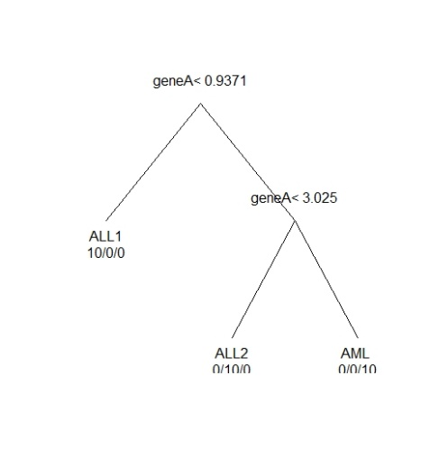Ekspresi gen yang optimal. Misalkan data ekspresi microarray tersedia sehubungan dengan pasien yang menderita dari tiga jenis leukemia disingkat ALL1, ALL2, dan AML. Gen A memiliki nilai ekspresi dari populasi (kelompok pasien) N (0,0,52) untuk ALL1, N (2,0,52) untuk ALL2, dan N (4,0,52) untuk AML.

1. Sensitivity versus speciﬁcity.
2. 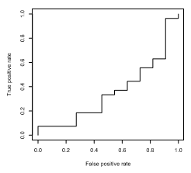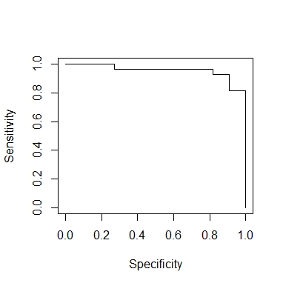Produce a sensitivity versus speciﬁcity plot for the gene expression values of CCND3 Cyclin D3.

> library(multtest);library(ROCR);data(golub)

> golub.clchanged <- -golub.cl +1

> pred <- prediction(golub[1042,], golub.clchanged)

> perf <- performance(pred, "sens", "spec")

> plot(perf)

1. In what sense does it resemble Figure 8.2.

Titik potong ditentukan pada data terkecil, yaitu -0.74, yang kemudian pada titik ini semua pasien diuji positif, sehingga tingkat positif palsu adalah 11/11 dan tingkat positif sejati adalah 27/27. Ini ditunjukkan oleh titik akhir (1,1) pada plot.Dapat diamati bahwa tingkat positif sejati jauh lebih rendah ketika seseorang bergerak pada sumbu horizontal dari kiri ke kanan. Ini sesuai dengan area di bawah kurva 0,35, yang kecil. Ini menggambarkan bahwa gen dapat mengekspresikan perbedaan besar sehubungan dengan prediksi status penyakit pasien.

1. Compute the area under the curve for sensitivity versus speciﬁcity curve.

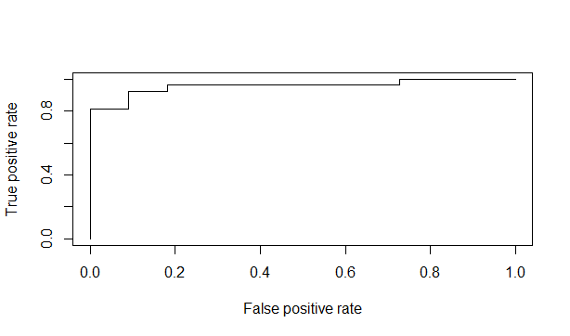

> #Ex 2

> library(ROCR)

> gol.true <- factor(golub.cl,levels=0:1,labels= c("TRUE","FALSE"))

> pred <- prediction(golub[1042,], gol.true)

> perf <- performance(pred, "tpr", "fpr" )

> performance(pred,"auc")

A performance instance

'Area under the ROC curve'

> plot(perf)

1. Comparing Classiﬁcation Methods. To obtain an idea on the misclassiﬁcation rate when there is no relation between the predictors and the factor indicating groups, we perform a small simulation study.
2. Construct a factor with 100 values one and two and a matrix with predictor variables of 500 by 4 with values from the normal distribution. Use the ﬁrst four letters of the alphabet for the column names.

> #3a

> library(rpart)

> predictors <- matrix(rnorm(100*4,0,1),100,4)

> colnames(predictors) <- letters[1:4]

> groups <- gl(2,50)

> simdata <- data.frame(groups,predictors)

> rp<-rpart(groups ~ a + b + c + d,method="class",data=simdata)

> predicted <- predict(rp,type="class")

> table(predicted,groups)

groups

predicted 1 2

1 38 10

2 12 40

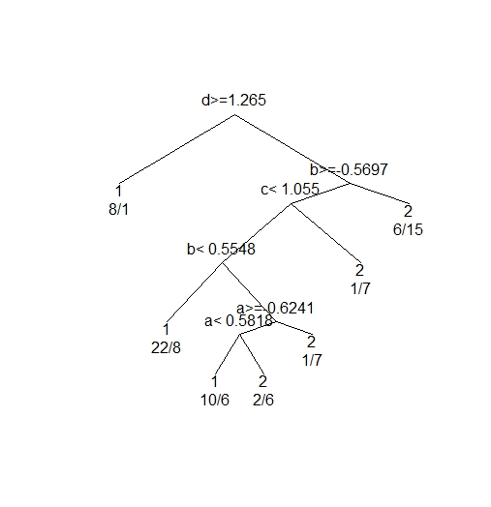

1. Use rpart to construct a recursive tree and report the misclassiﬁcation rate. Comment on the results.
2. Do the same for support vector machines.

> library(e1071)

> svmest <- svm(predictors, groups, data=df, type = "C-classification", kernel = "linear")

> svmpred <- predict(svmest, predictors, probability=TRUE)

> table(svmpred, groups)

groups

svmpred 1 2

1 50 50

2 0 0

> plot(rp, branch=0,margin=0.1); text(rp, digits=3, use.n=TRUE)

1. Do the same for neural networks.

> library(nnet)

> nnest <- nnet(groups ~ ., data = simdata, size = 5,maxit = 500, decay = 0.01, MaxNWts = 5000)

# weights: 31

initial value 72.875957

iter 10 value 61.281306

iter 20 value 48.491034

iter 30 value 44.000429

iter 40 value 41.593852

iter 50 value 41.253020

iter 60 value 41.238766

iter 70 value 41.238492

iter 80 value 41.238437

final value 41.238433

converged

1. Think through your results and comment on these.

Tingkat kesalahan klasifikasi akan menurun berbanding terbalik dengan predictor yang diberikan. Semakin banyak predictor, semakin kecil tingkat kesalahan pada klasifikasi.

1. Prediction of achieved remission. For the ALL data from its ALL library the patients are checked for achieving remission. The variable ALL$CR has values CR (became healthy) and REF (did not respond to therapy; remain ill).
2. Construct an expression set containing the patients with values on the phenotypical variable remission and the gene expressions with a signiﬁcant p-value on the t-test with the patient groups CR or REF.
3. 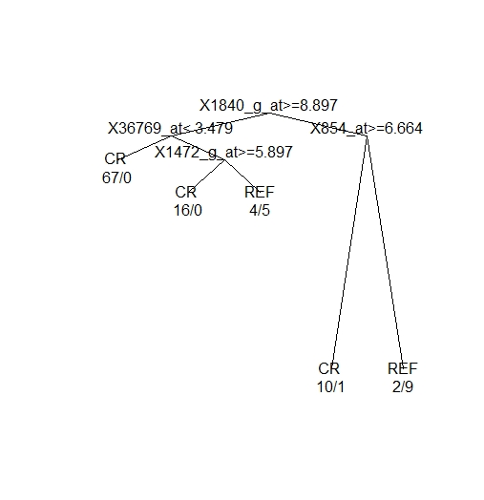Use recursive partitioning to predict the remission. Report the misclassiﬁcation rate and the names of the genes that play a role in the tree.

> ALLrem <- ALL[,which(pData(ALL)$remission %in% c("CR","REF"))]

> remfac <-factor(pData(ALLrem)$remission)

> pano <- apply(exprs(ALLrem),1,function(x) t.test(x ~ remfac)$p.value)

> names <- featureNames(ALLrem)[pano<.001]

> ALLremsel<- ALLrem[names,]

> data <- data.frame(t(exprs(ALLremsel)))

> all.rp <- rpart(remfac ~., data, method="class", cp=0.001)

> plot(all.rp, branch=0,margin=0.1); text(all.rp, digits=3, use.n=TRUE)

> rpart.pred <- predict(all.rp, type="class")

> table(rpart.pred,remfac)

remfac

rpart.pred CR REF

CR 93 1

REF 6 14

> 7/(93+1+6+14)

[1] 0.06140351

> mget(c("1840_g_at","36769_at","1472_g_at","854_at"), env = hgu95av2GENENAME)

$`1840_g_at`

[1] "RAN, member RAS oncogene family"

$`36769_at`

[1] "RB binding protein 5, histone lysine methyltransferase complex subunit"

$`1472_g_at`

[1] "MYB proto-oncogene, transcription factor"

$`854_at`

[1] "BLK proto-oncogene, Src family tyrosine kinase"

1. Gene selection by area under the curve. A strategy of selecting genes is to compute the auc for each gene and to use the best 10 for further investigation. Compute the auc for each row with gene expressions of the Golub at al. (1999) data. Collect these in a vector and select the ten best. Is ”CCND3 Cyclin D3” among these?

> #5

> library(ROCR); data(golub, package = "multtest")

> gol.true <- factor(golub.cl,levels=0:1,labels= c("TRUE","FALSE"))

> auc.values <- apply(golub,1,

+ function(x) performance(prediction(x, gol.true),"auc")@y.values[[1]])

> o <- order(auc.values,decreasing=TRUE)

> golub.gnames[o[1:25],2]

[1] "TCF3 Transcription factor 3 (E2A immunoglobulin enhancer binding factors E12/E47)"

[2] "Macmarcks"

[3] "VIL2 Villin 2 (ezrin)"

[4] "TOP2B Topoisomerase (DNA) II beta (180kD)"

[5] "C-myb gene extracted from Human (c-myb) gene, complete primary cds,   
 and five complete alternatively spliced cds"

[6] "RETINOBLASTOMA BINDING PROTEIN P48"

[7] "RB1 Retinoblastoma 1 (including osteosarcoma)"

[8] "CCND3 Cyclin D3"

[9] "ALDR1 Aldehyde reductase 1 (low Km aldose reductase)"

[10] "T-COMPLEX PROTEIN 1, GAMMA SUBUNIT"

[11] "SPTAN1 Spectrin, alpha, non-erythrocytic 1 (alpha-fodrin)"

[12] "Inducible protein mRNA"

[13] "Translational initiation factor 2 beta subunit (elF-2-beta) mRNA"

[14] "NUCLEOLYSIN TIA-1"

[15] "Putative enterocyte differentiation promoting factor mRNA, partial cds"

[16] "IEF SSP 9502 mRNA"

[17] "ACADM Acyl-Coenzyme A dehydrogenase, C-4 to C-12 straight chain"

[18] "PROTEASOME IOTA CHAIN"

[19] "X-LINKED HELICASE II"

[20] "Stimulator of TAR RNA binding (SRB) mRNA"

[21] "MYL1 Myosin light chain (alkali)"

[22] "Transcriptional activator hSNF2b"

[23] "HKR-T1"

[24] "ADA Adenosine deaminase"

[25] "Transcriptional activator hSNF2b"